RunBook For Updating Auto-Scaling Group

* Login to AWS Management Consul and click on EC2 Service

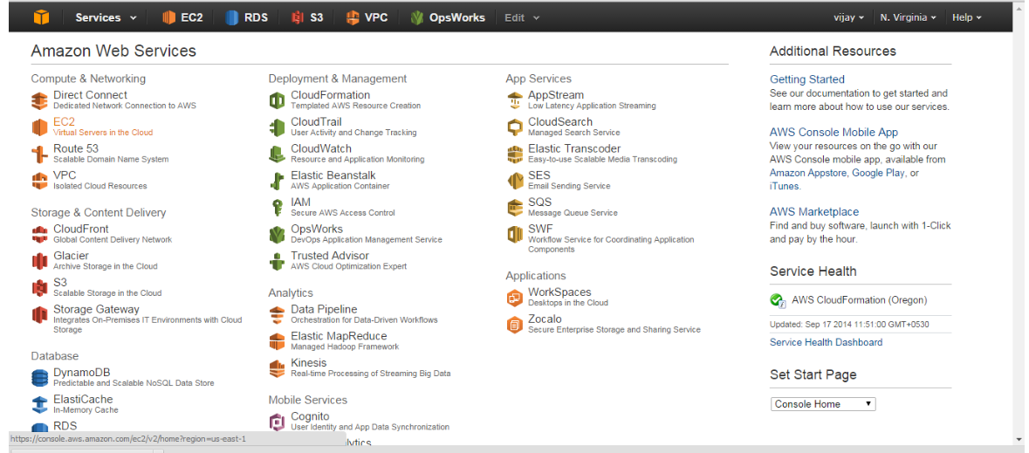

* Click on Instance tab from left panel

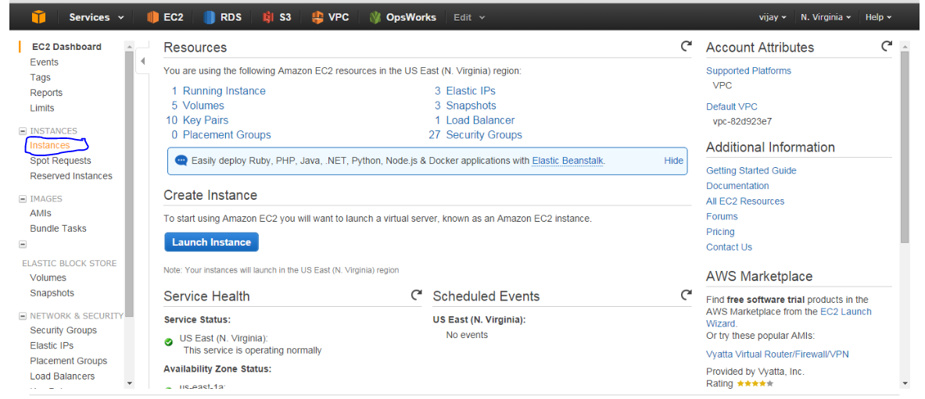

* Select your base server and goto actions and click on create image.

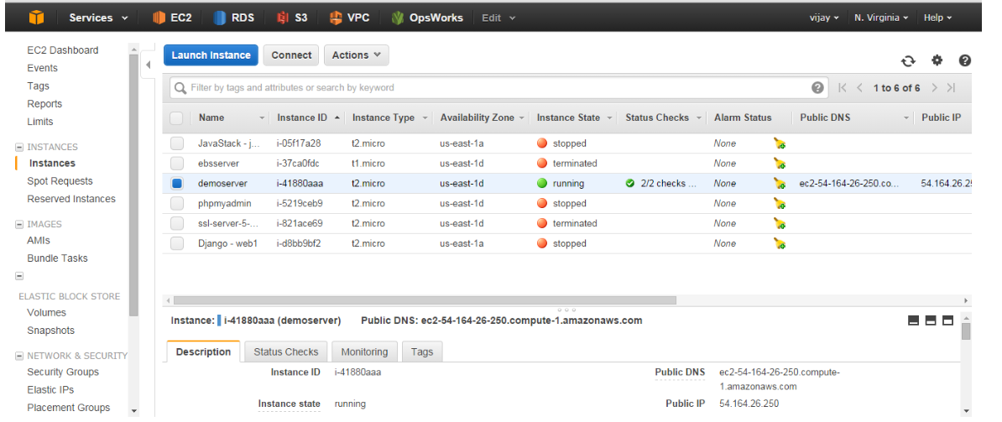

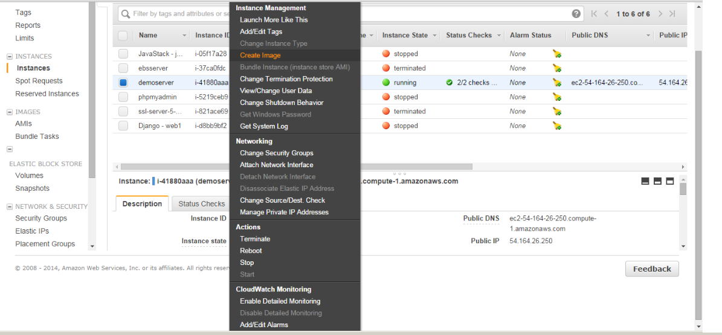

* Give Name to the image and click on create image tab and click on close.

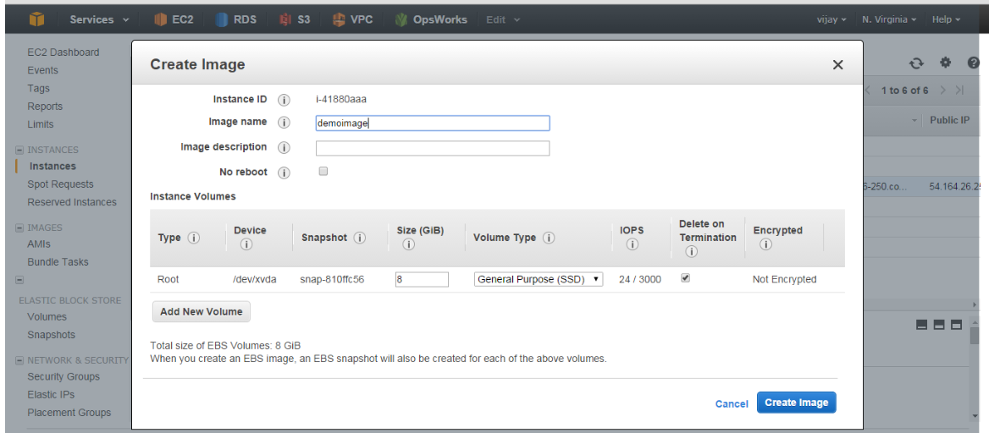

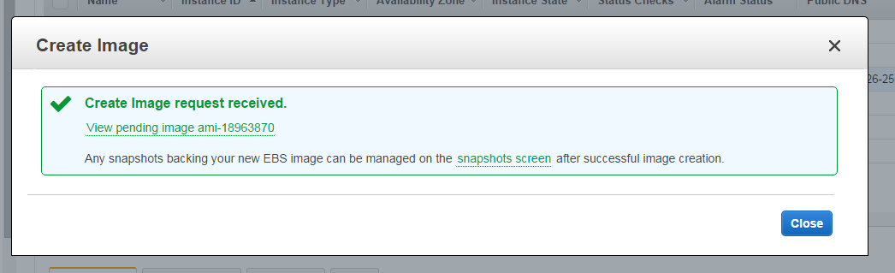

* Click on AMIs tab on the left panel to view newly created image.

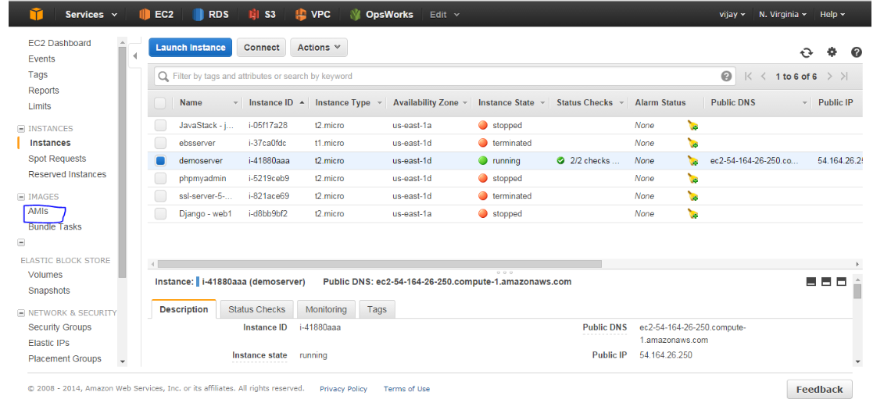

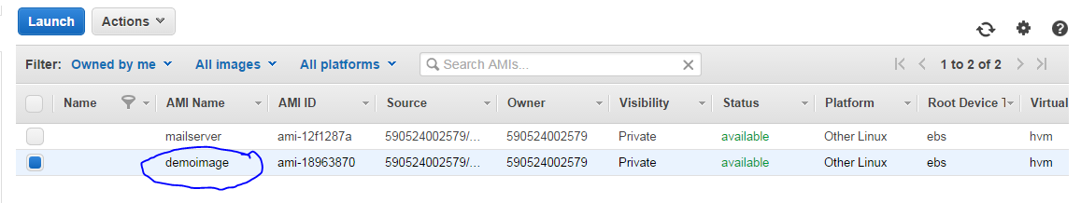

* Click on Launch Configuration from left panel to create launch configuration.

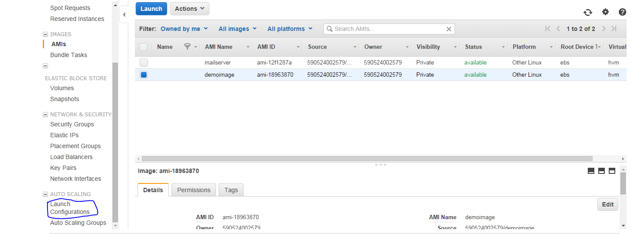

Click on create Auto Scaling group & click on create launch configuration & select My AMIs to select the image.

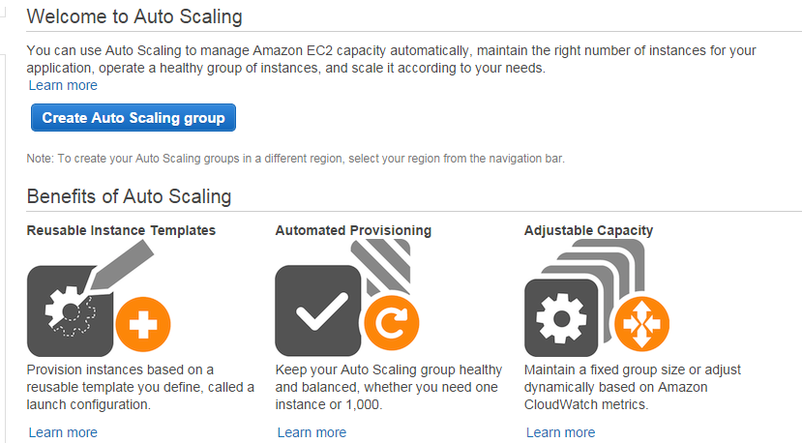

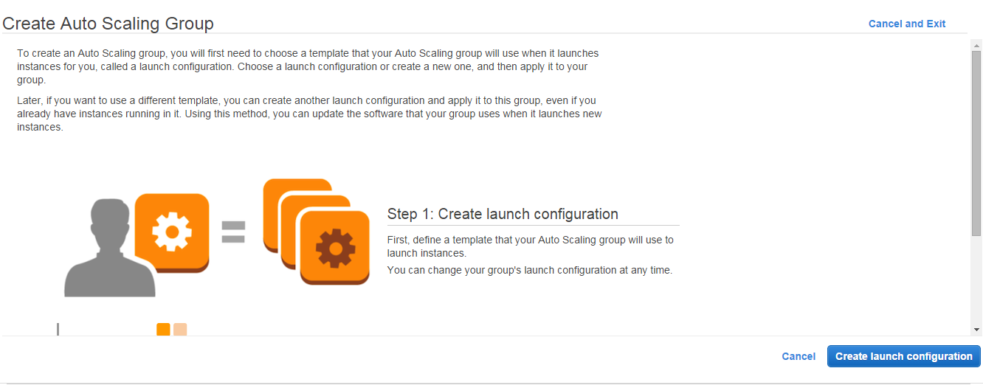

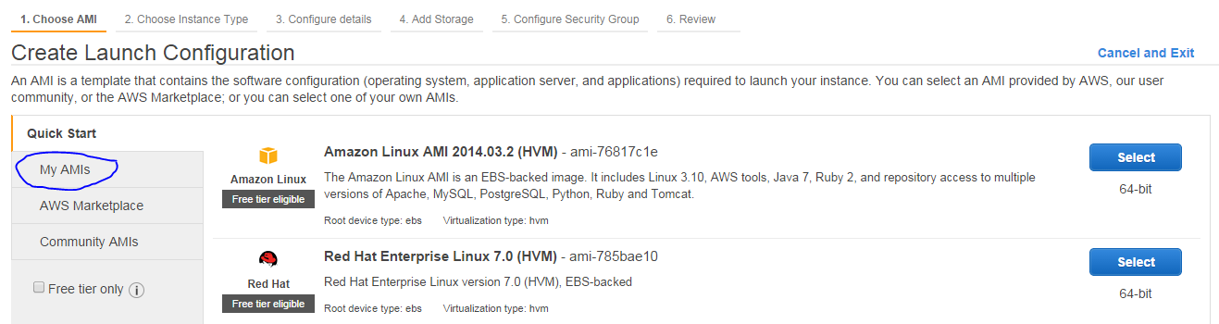

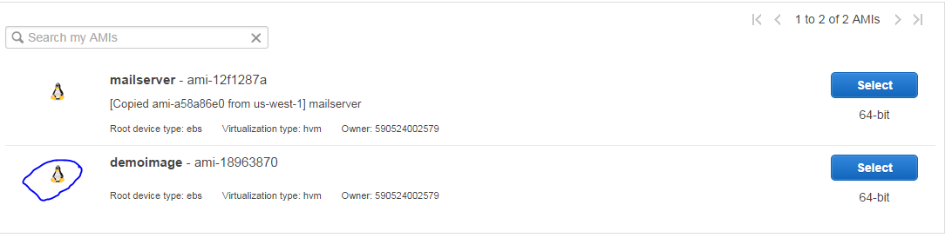

* Select instance type – Recommended (As per the base instance type)

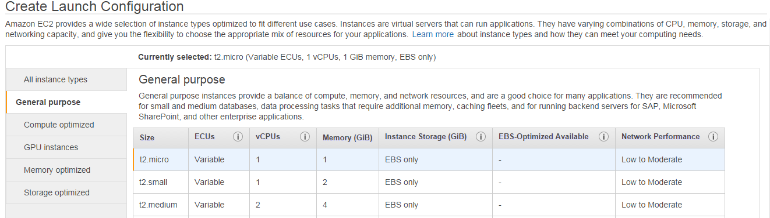

* Name the Launch Configuration & click on Add Storage & click on configure security groups.

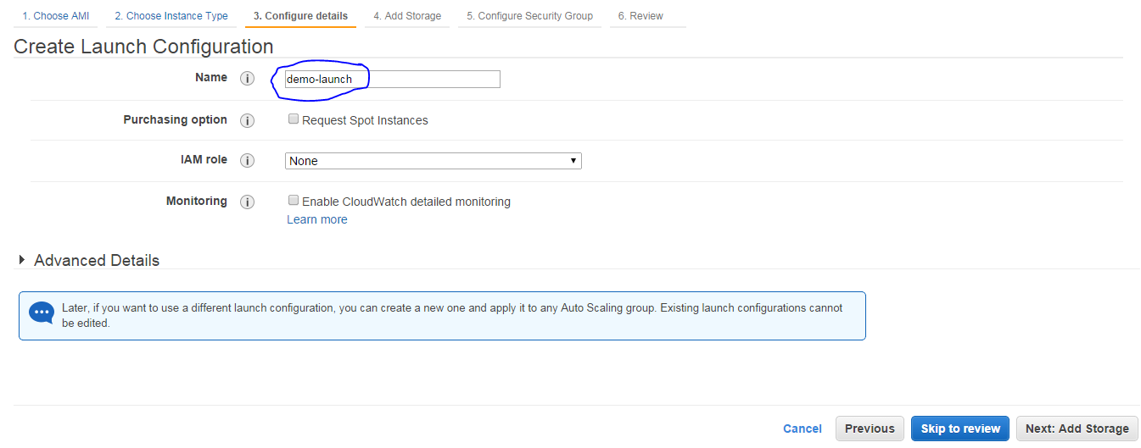

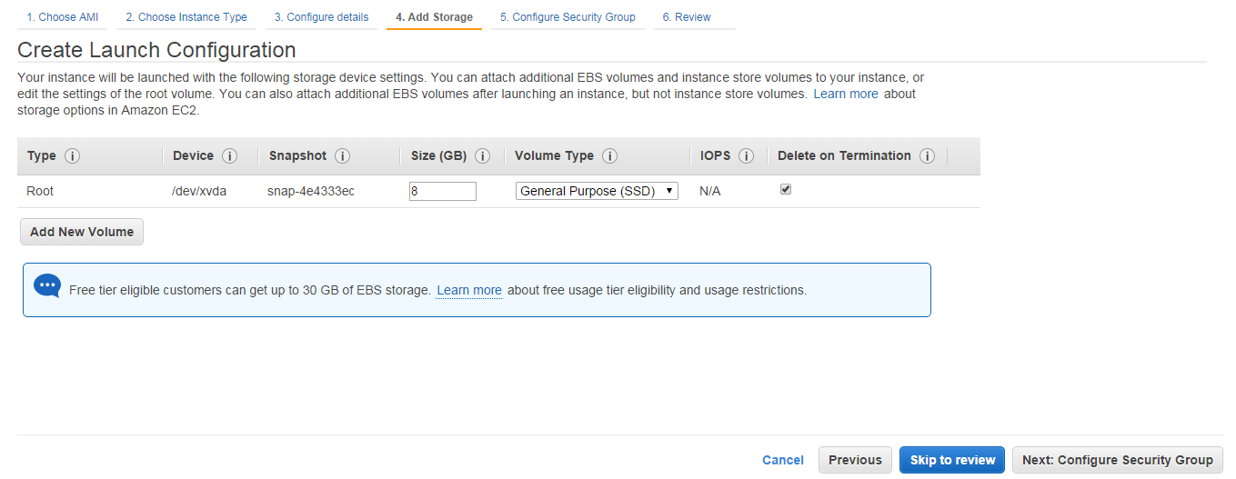

* Select the same exciting security group which you have created for base instance and click on review tab at bottom right.

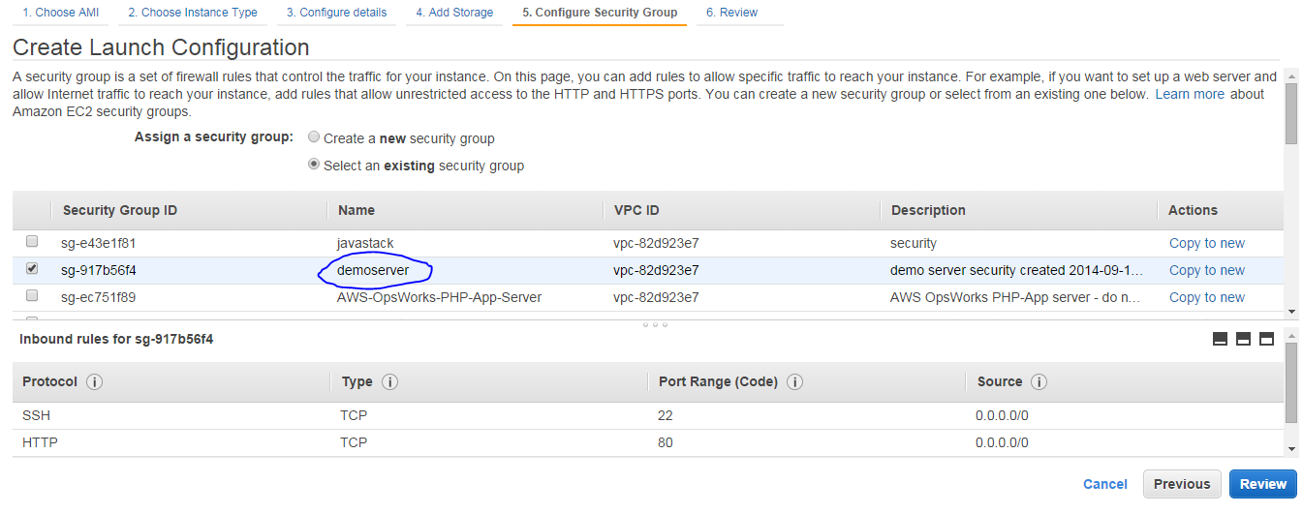

* Review the status of total process and click on create launch configuration

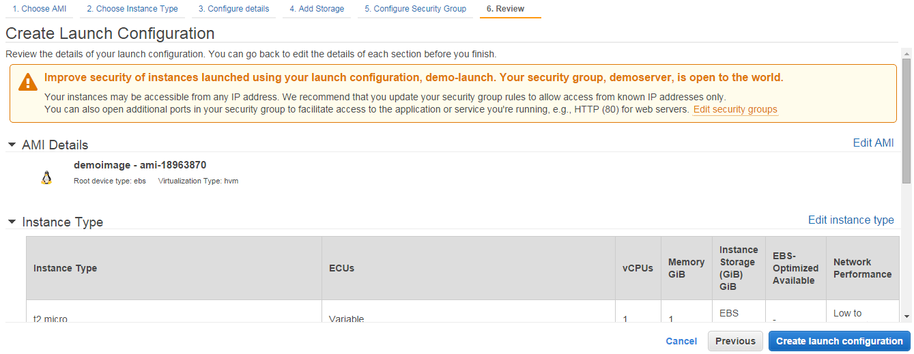

* Select the existing key pair and check the acknowledge box anc click on create launch configuration.

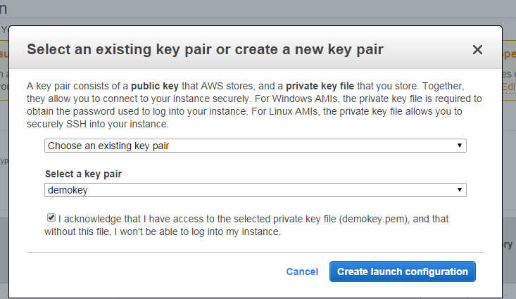

* Now create Auto Scaling Group give Group Name , Network – Default VPC , Subnet – Default subnet.
* Click on Advanced details & check the ELB ckeck box and select the load balancer .
* Click on configure scaling polices at bottom right.

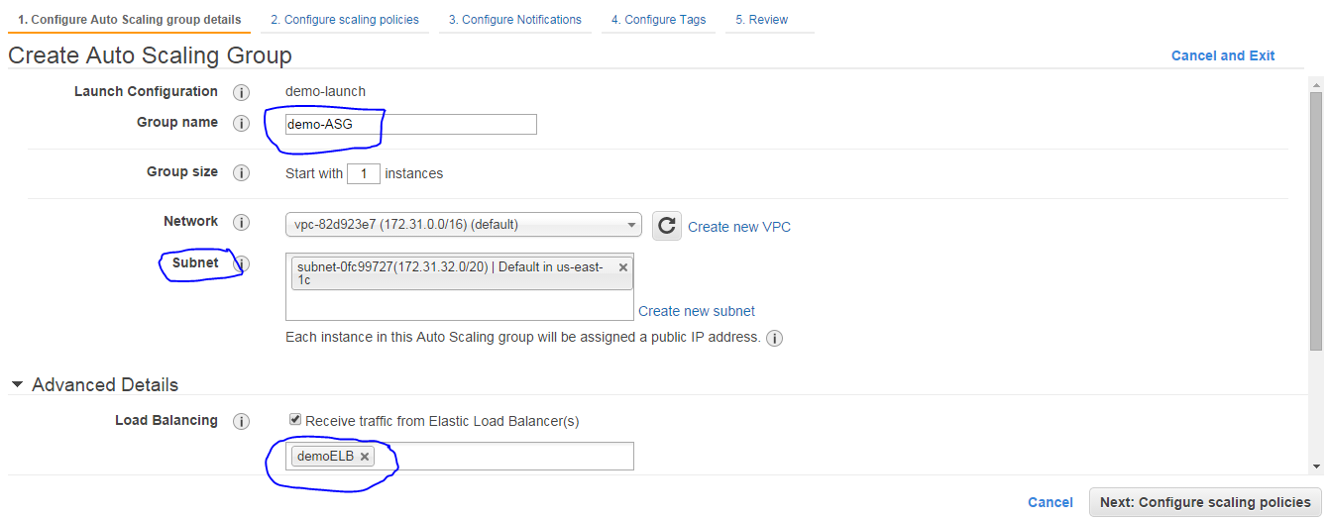

* Select second radio button and configure alarm for Increasing group size police as well as Decreasing group size police. 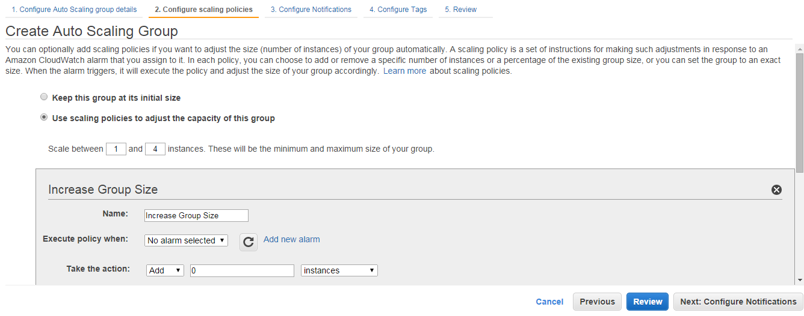
* 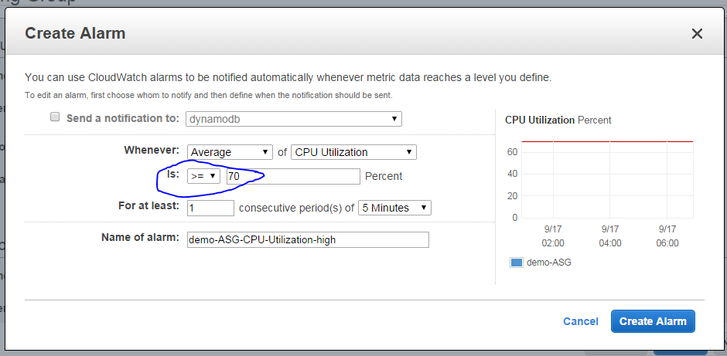 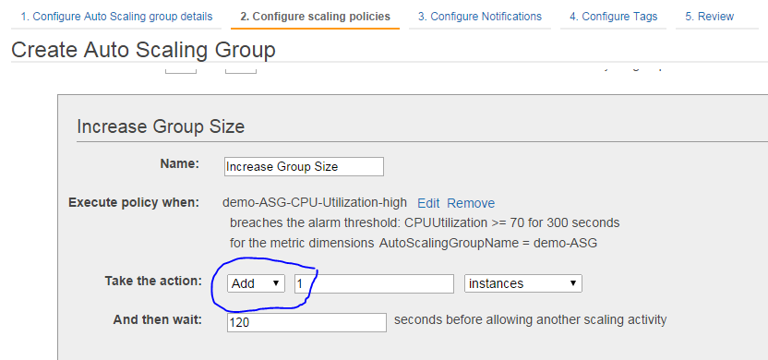 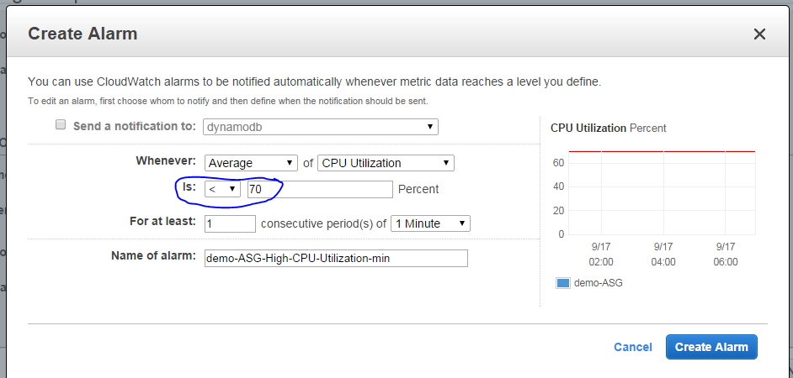 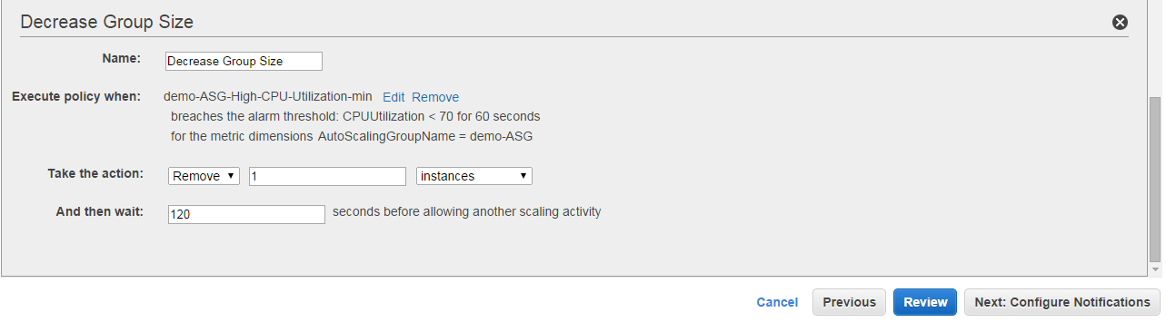
* And click on Review Tab.



* Review the Auto Scaling Group details and click on create Auto Scaling Group & click on close.

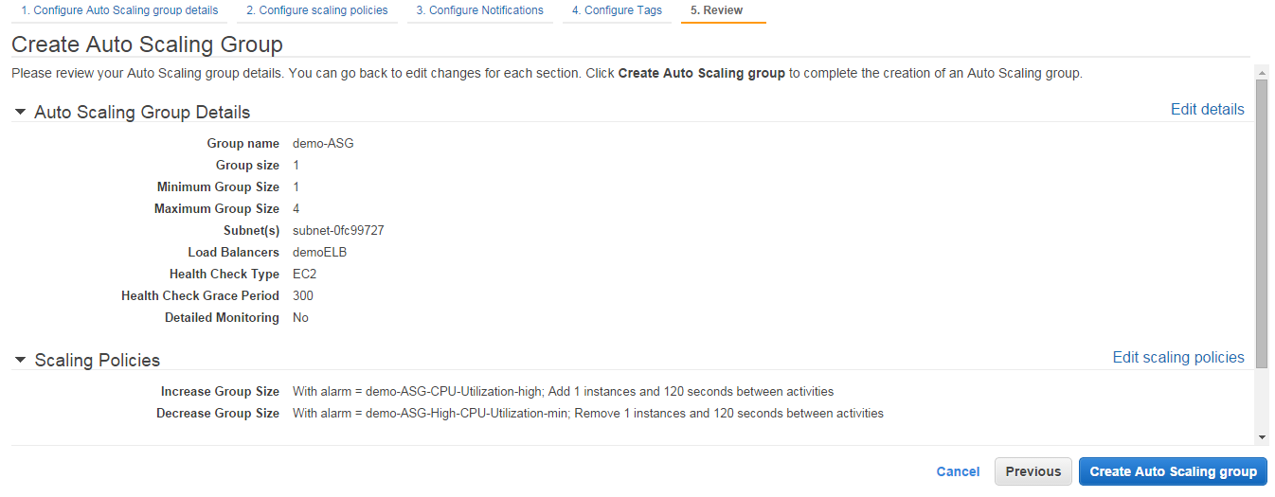 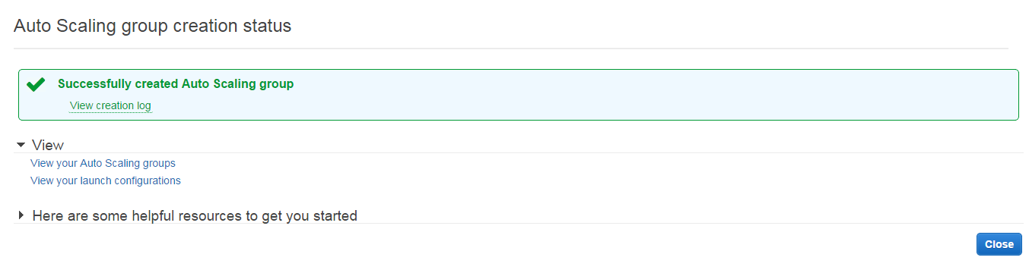

* Now one Auto scaling group is created in your auto scaling group panel.

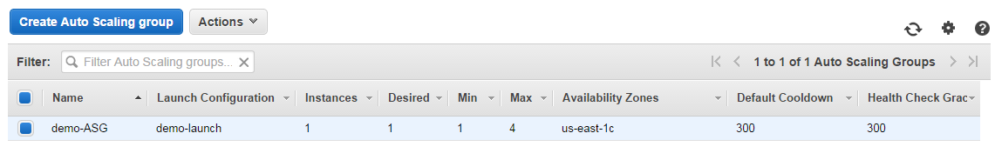

* Now go back to EC2 Instance there you will find one ASG Instance Automatically Created.

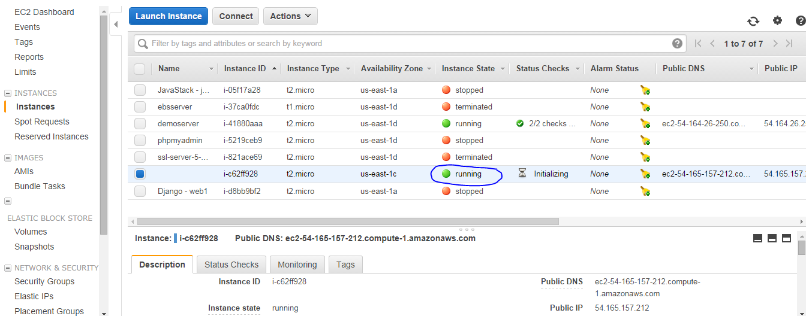

* click on load balancer in the description you will find two instances running and two are in service.

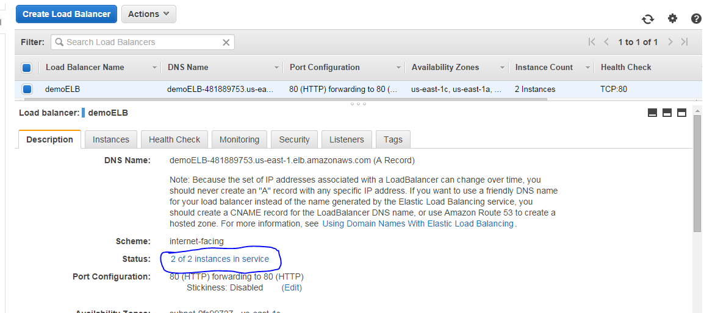

* Now Auto scaling group is updated successfully and your instances are running healthy.

**Note:** Once done with your Launch configuration and auto scaling group please remove the old Launch configuration and auto scaling group for security purpose.

All The Best ☺

* 